

Compsoft Technologies

Bangalore, Karnataka

AN INTERNSHIP REPORT ON

“STICKY NOTES”

## BACHELOR OF ENGINEERING

## IN

#### INFORMATION SCIENCE AND ENGINEERING

##### 

##### Submitted by: DEEPTHI N (1EP20IS028)

##### Under the Supervision of: Sumukh S Jadhav

##### 

EAST POINT COLLEGE OF ENGINEERING AND

TECHNOLOGY

(Affiliated to Visvesvaraya Technological University and Approved by AICTE, New Delhi) Accredited By NAAC with ‘A’ Grade

ISO 9001-2015 and 14001-2015 certified Institute

**BENGALURU, KARNATAKA 560049**

**2021-2022**

**ABOUT THE COMPANY**

CST is a digital service provider that aims to provide software, designing and marketing solutions to individuals and businesses. At CST , we believe that service and quality is the key to success

We provide all kinds of technological and designing solutions from Billing Software to Web Designs or any custom demand that you may have. Experience the service like none other!

Some of our services include:

* Development - We develop responsive, functional and super-fast websites.
* We keep User Experience in mind while creating websites. A website should load quickly and shouldbe accessible even on a small view-port and slow internet connection.
* Mobile Application - We offer a wide range of professional Android, iOS& Hybrid app development services for our global clients, from a start up to a large enterprise.
* Design - We offer professional Graphic design, Brochure design & Logo design. We are expertsin crafting visual content to convey the right message to the customers.
* Consultancy - We are here to provide you with expert advice on your design and development requirement.
* Videos - We create a polished professional video that impresses your audience.

# CONTENTS

# Overview of the project

# About

# Tools Used

# Implementation

# Snapshots

# Biblography

# 

### OVERVIEW OF THE PROJECT

Project Name**:** STICKY NOTES

Project objective

To create a program that allows you to add sticky notes to your screen, Sticky notes represent information that is crucial to managing the project.

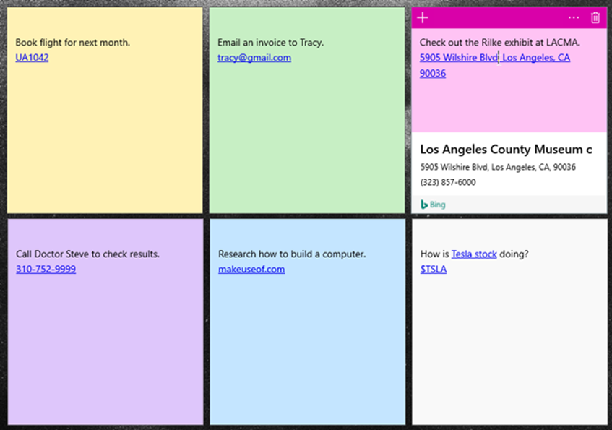

**STICKY NOTES**

* With Sticky Notes, you can create notes, type, ink or add a picture, add text formatting, stick them to the desktop, move them around there freely, close them to the Notes list, and sync them across devices and apps.
* You can use the sticky note as a reminder with a description of which place has what stuff. It can save your time.
* Sticky notes are very cost-effective and can be used for highlighting important message for its vibrant color it adds contrast to the standard books.
* It’s made for temporarily attaching notes to documents and other surfaces.
* Simple Sticky Notes has a user-friendly interface and lets you print, copy, and share notes anytime you want.
* You can change the size, color, transparency, font of any note as per your

preference.

* You can alter the notes anytime can add delete and the other notes will

not be affected by the modification

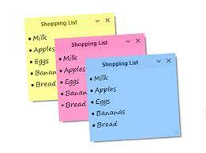

### TOOLS USED

**Software Requirements**

* Visual Studio Code.
* Google Chrome latest version
* Front End: HTML, CSS, JS
* Linux 7.1 or Windows XP/7/8/10 OS or Mac OS

**Hardware Requirements**

|  |  |  |
| --- | --- | --- |
|  | Minimum | Recommended |
| Operating system | Xbox/Windows 10 Version 1903 or later | |
| Architecture | ARM, x64, x86 | |
| Keyboard | Integrated Keyboard | N/A |
| Notes | N/A | Windows 10 Intel-based desktops |

|  |  |  |
| --- | --- | --- |
|  |  |  |
|  |  |  |
|  |  |  |
|  |  |  |
|  |  |  |

# IMPLEMENTATION

PART 1- HTML CODE

<!DOCTYPE html>

<html lang="en">

<head>

    <meta charset="UTF=8">

    <meta name="viewport" content="width=device-width, initial-scale=1.0">

    <link rel="stylesheet" href="https://fonts.googleapis.com/css?family=Architects+Daughter">

    <link rel="stylesheet" href="https://cdn.jsdelivr.net/npm/bootstrap@5.1.3/dist/css/bootstrap.min.css">

    <link rel="stylesheet" href="style.css">

    <title>Document</title>

</head>

<body>

<div class="main-container">

        <div class="container1">

            <button class="btn btn-success" onclick="typenote()">Create note</button>

        </div>

        <div class="container2"></div>

        <div class="container3" id="Box2">

            <form>

                <textarea id="note-text" placeholder="Write note..." maxlength="96"></textarea>

                <svg id="checkIcon" width="16" height="16" fill="currentColor" class="bi bi-check-circle" viewBox="0 0 16 16" xmlns="http://www.w3.org/2000/svg">

                    <path fill-rule="evenodd" d="M8 15A7 7 0 1 1 8 1a7 7 0 0 1 0 14zm0 1A8 8 0 1 0 8 0a8 8 0 0 0 0 16z"/>

                    <path fill-rule="evenodd" d="M10.97 4.97a.235.235 0 0 0-.02.022L7.477 9.417 5.384 7.323a.75.75 0 0 0-1.06 1.06L6.97 11.03a.75.75 0 0 0 1.079-.02l3.992-4.99a.75.75 0 0 0-1.071-1.05z"/>

                  </svg>

                <svg id="x-Icon" width="16" height="16" fill="currentColor" class="bi bi-x-circle" viewBox="0 0 16 16" xmlns="http://www.w3.org/2000/svg">

                    <path  fill-rule="evenodd" d="M8 15A7 7 0 1 1 8 1a7 7 0 0 1 0 14zm0 1A8 8 0 1 0 8 0a8 8 0 0 0 0 16z"/>

                    <path  fill-rule="evenodd" d="M4.646 4.646a.5.5 0 0 1 .708 0L8 7.293l2.646-2.647a.5.5 0 0 1 .708.708L8.707 8l2.647 2.646a.5.5 0 0 1-.708.708L8 8.707l-2.646 2.647a.5.5 0 0 1-.708-.708L7.293 8 4.646 5.354a.5.5 0 0 1 0-.708z"/>

                  </svg>

            </form>

        </div>

        <script src="script.js"></script>

</body>

</html>

PART 2-CSS CODE

* {

    padding: 0;

    margin: 0;

}

body {

    background: #c68c53a8;

    font-family: "Architects Daughter";

    font-size: 24px;

}

.main-container {

    width: 95%;

    margin: auto;

}

.container1 {

    margin-left: 5%;

}

.container2 {

    display: flex;

    justify-content: flex-start;

    flex-wrap: wrap;

    margin-top: 20px;

    margin-left: 5%;

}

.container3 {

    /* display:none; */

    position: absolute;

    top: 26%;

    left: 40%;

}

textarea {

    box-shadow: 10px 10px 24px 0px rgba(0, 0, 0, 0.75);

    outline: none;

    border: none;

    width: 275px;

    height: 275px;

    padding: 40px 25px 25px;

}

sv {

    color: grey;

}

#checkIcon {

    position: absolute;

    right: 17%;

    top: 4%;

}

#x-Icon {

    position: absolute;

    right: 5%;

    top: 4%;

}

PART 3-JS CODE

var container2 = document.getElementsByClassName("container2")[0];

var container3 = document.getElementsByClassName("container3")[0];

var checkIcon = document.getElementById("checkIcon");

var xIcon = document.getElementById("x-Icon");

var i = 0;

xIcon.addEventListener("click", function() {

    typeNote();

})

checkIcon.addEventListener("click", function() {

    createNote();

})

/*function typeNote() {

    alert("x mark");

    if (container3.style.display == "none") {

        container3.style.display == "block";

    } else {

        alert("else cond");

        //container3.style.display == "none";

        var Box = document.getElementById("Box2");

        Box.style.display == "none";

    }

}*/

function typeNote() {

    var x = document.getElementById("Box2");

    if (x.style.display === "none") {

        x.style.display = "block";

    } else {

        x.style.display = "none";

    }

}

function createNote() {

    //alert("create note");

    var noteText = document.getElementById("note-text").value;

    var node0 = document.createElement("div");

    var node1 = document.createElement("h1");

    node1.innerHTML = noteText;

    node1.setAttribute("style", "width:250px;height:250px;fonst-size:26px;padding:25px;margin-top:10px;overflow:hidden; box-shadow:0px 10px 24px 0px rgba(0,0,0,0.75)");

    node1.style.margin = margin();

    node1.style.transform = rotate();

    node1.style.background = color();

    node0.appendChild(node1);

    container2.insertAdjacentElement("beforeend", node0);

}

function margin() {

    var random_margin = ["-5px", "1px", "5px", "10px", "15px", "20px"];

    return random_margin[Math.floor(Math.random() *

        random_margin.length)];

}

function rotate() {

    var random_rotate = ["rotate(3deg)", "rotate(1deg)",

        "rotate(-1deg)", "rotate(-3deg)", "rotate(-5deg)", "rotate(-10deg)"

    ];

    return random_rotate[Math.floor(Math.random() *

        random_rotate.length)]

}

function color() {

    var random_color = ["#c2ff3d", "#ff3de8", "#3dc2ff",

        "#04e022", "#bc83e6", "#ebb328"

    ];

    if (i > random_color.length - 1) {

        i = 0;

    }

    return random_color[i++];

}

### 

### SNAPSHOT

### 

### 

BIBLIOGRAPHY

* [www.youtube.com](http://www.youtube.com)
* [www.w3schools.com](http://www.w3schools.com)
* [www.boostrap.com](http://www.boostrap.com)
* [www.takeiteasyengineers.com](http://www.takeiteasyengineers.com)
* [www.google.com](http://www.google.com)